Sean Escot

Professor Richard

Fundamentals of Data Visualization

May 7, 2021

Final Project

My Questions:

1. Who is the top streamer?
2. Compare the three top streamers.
3. How much do mature content creators make up for the entire website compared to family friendly?
4. Hypothesis - Mature content creators are more popular since they have more average viewers and followers than family friendly content creators

Report Questions:

1. Question 1
   1. I chose this Data set because it piqued my interest and since i was fond of video games and video content. It seemed to suit me the most.
   2. The data is meant to represent who is the best streamer and most popular video out of the three factors that I think is the most relevant. The Fifth and Sixth figure is meant to answer my hypothesis, which family creators are more popular essentially.
   3. The variables included are Channel, Watch Time, Stream Time, Peak Viewers, Average Viewers, Followers, Followers gained, Viewers Gained, Partnered, and Mature.
   4. None
2. Question 2
   1. I find it interesting because as i mentioned before, I like playing video games in my spare time and it caught my interest when looking through other data sets.
   2. The questions that are relevant is :
      1. Who is the top streamer?
      2. Compare the three top streamers.
      3. How much do mature content creators make up for the entire website compared to family friendly?
   3. I want to explore it because it just fascinates me how much streamers there are, before playing video games was just a hobby and something to waste time in, now people are actually putting in work and making a living off of it. I wanted to see if being for a mature audience was a way to get more views or perhaps doing family content is the one. I was very curious to see what this offers.
3. Question 3
   1. Hypothesis - Mature content creators are more popular since they have more average viewers and followers than family friendly content creators
   2. ---
4. Question 5
   1. Over the experiments I have conducted in R, Family friendly have more views and followers than mature streamers have. There are times where i was stumped because I was thinking that this type of data set was meant for Histograms but it turns out, it was actually a bar graph. Yes they produce somewhat the same figure but are treated so very differently.
   2. Figure 1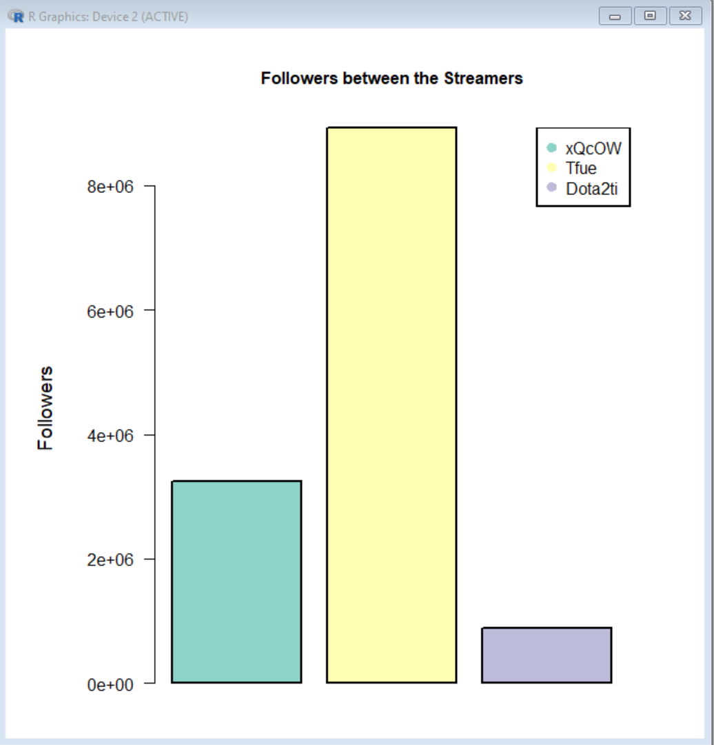
   3. Figure 2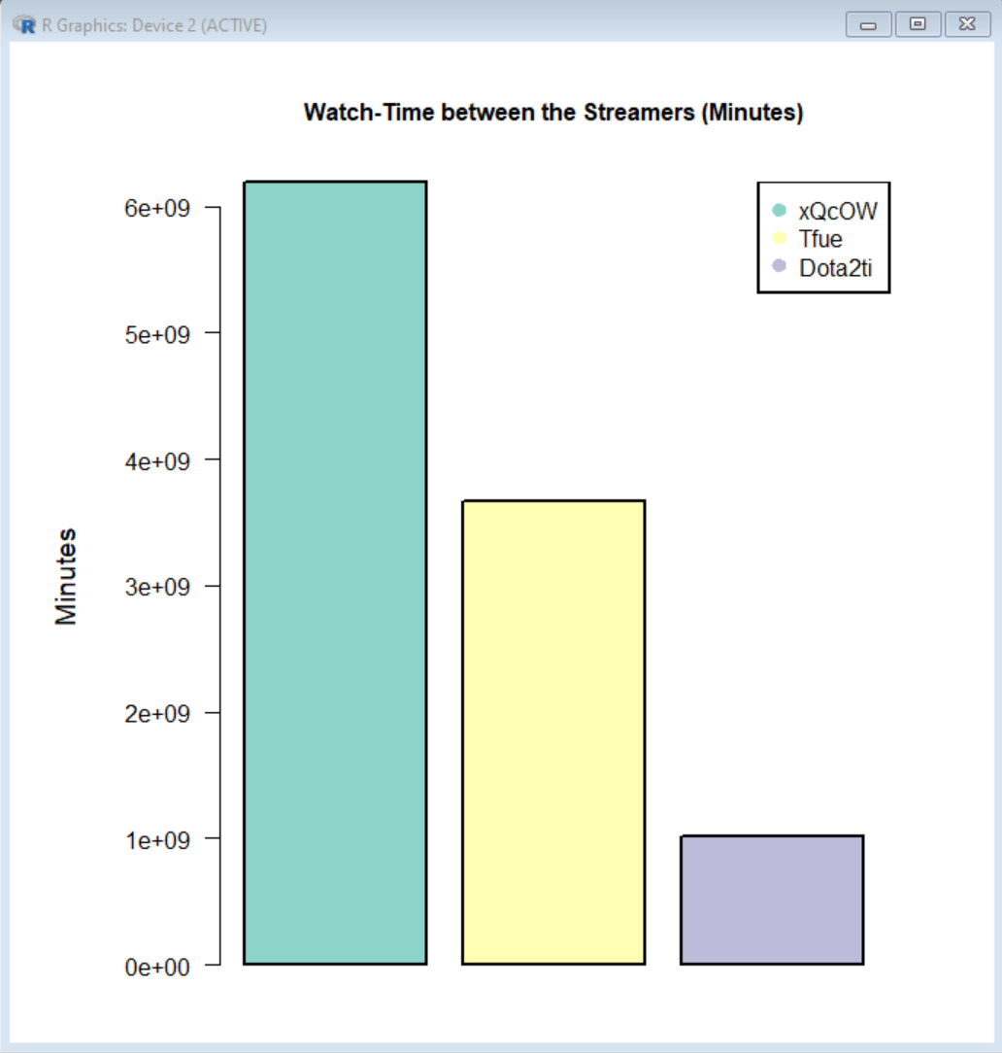
   4. Figure 3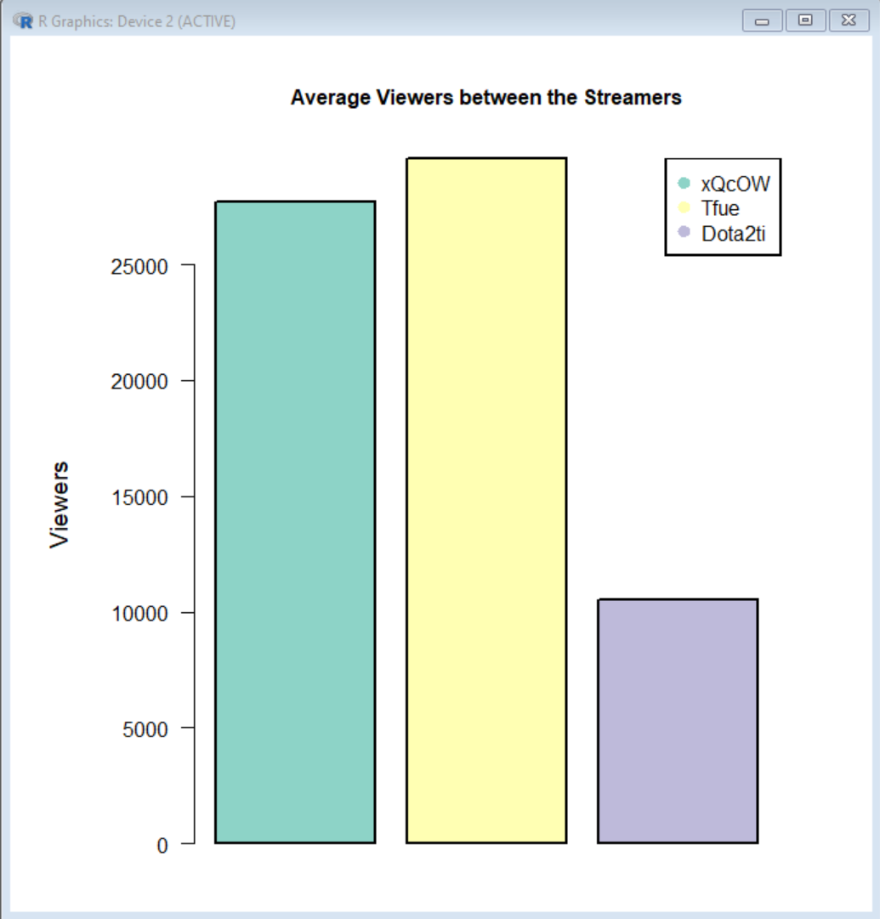
   5. Figure 4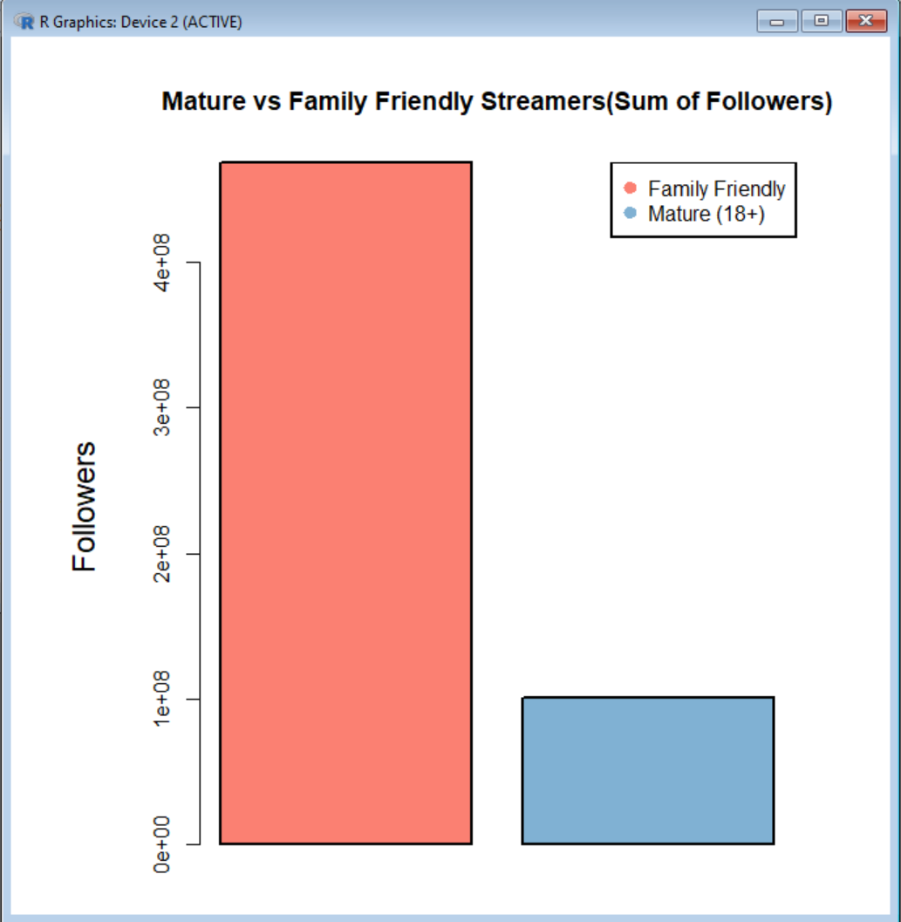
   6. Figure 5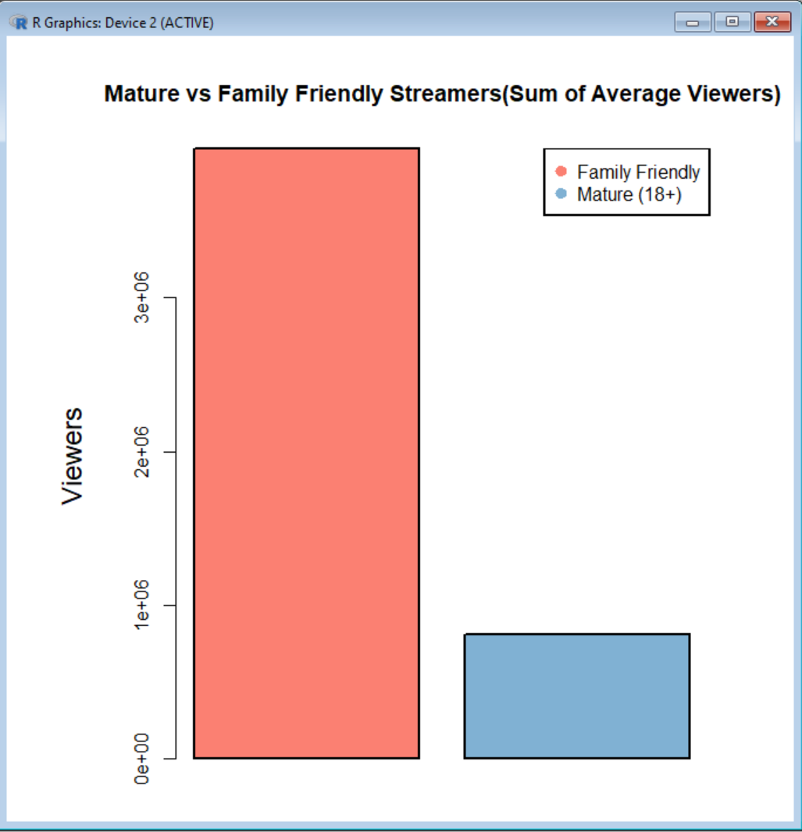
   7. Figure 6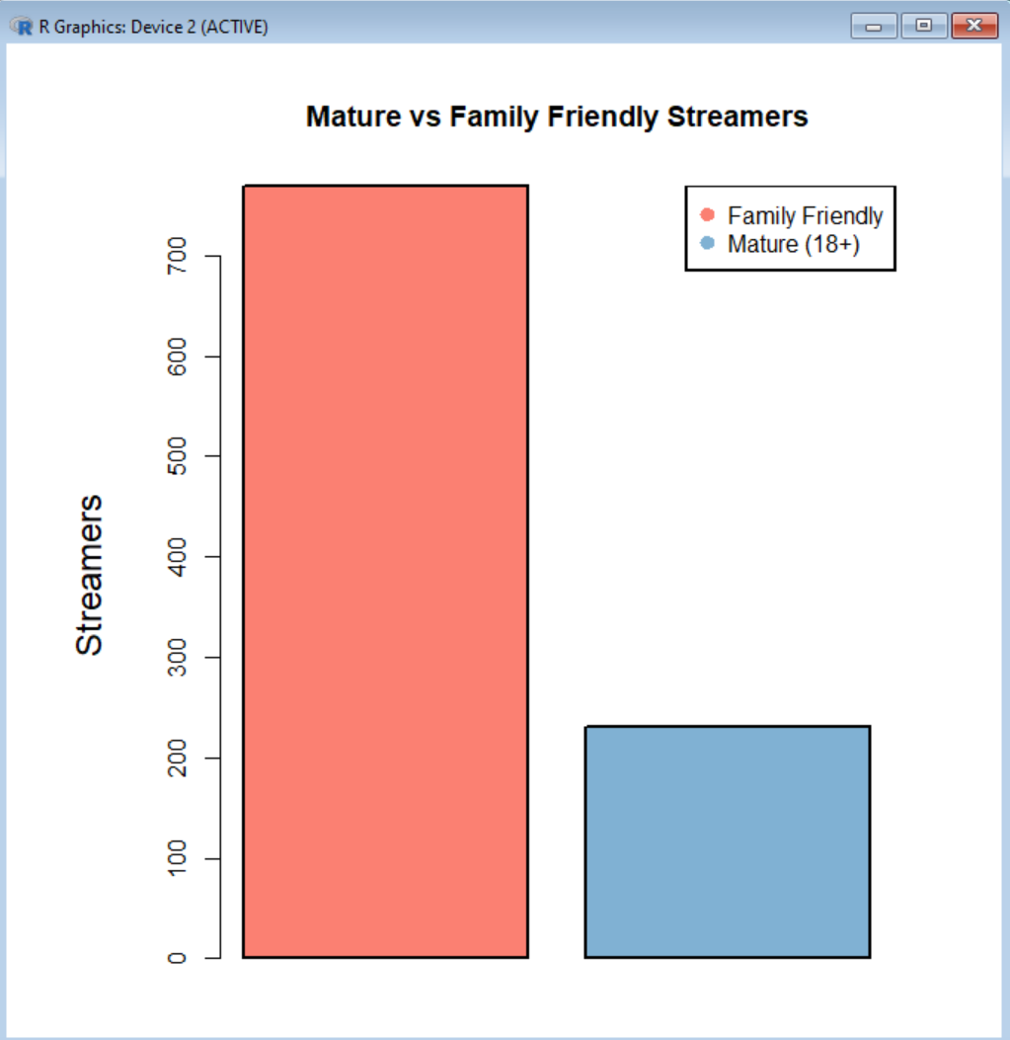
5. Conclusion
   1. In conclusion, family friendly creators are more popular and a larger group than Mature creators. This means that family friendly creators are more dominant in twitch than Mature creators. They have more viewers and more followers by a long shot.
   2. There is nothing really to take home, rather than to satisfy what the three big streamers are and to see if mature creators are more popular than family friendly. This was just a fun little experiment.